REMEDY ACKNOWLEDGEMENT SYSTEM


 | Prepared By / Last Updated By | Reviewed by | Approved By
Name
Role | Team Member | Team Member | Scrum Master
Signature
Date

Table of Contents
1.0 Introduction 3
1.1 Purpose & Scope of the document 3
1.2 Intended Audience 3
1.3 Use case ‘Remedy Acknowledgement System’ 3
1.3.1 Use case attributes 3
1.3.2 Use Case Model 4
1.3.3 Business Rules 4
1.3.4 UI Requirements 4
1.3.5 UI Field Validations 5
1.4 Use case ‘User Credential Authentication’ 6
1.4.1 Use case attributes 6
1.4.2 Use Case Model 7
1.4.3 Business Rules 7
1.4.4 UI Requirements 7
2.0 Database Design 8
2.1 Tables Structure 8
3.0 Change Log 10

Introduction

Purpose & Scope of the document
The purpose of this Use case document is to systematically capture requirements for the project and the system to be developed in terms of use cases. Functional use cases are captured in this document. It also serves as the input for the project scoping.

The scope of this document is limited to addressing the use cases from a user, quality, and non-functional perspective.

Intended Audience
Each member of the project team

Use case ‘User Registration’ & ‘User Login’

Use case attributes
Use Case Description:

This use case deals with the capture of user details. The ‘user’ here shall be the operator of the remedy tracking and adding issues.

Scope:

- User registration & Login

Actors:

- User – the operator

Trigger:

Click ‘Submit’ button in the page

Pre-Condition:

User being able to access the homepage & get redirected to the ‘User Registration’ page upon click of ‘Register if new’ link or ‘User Login’ by clicking on Login Link.

Post Condition:

User is in the enrollment page & submit details

Flow of Events:

User at homepage → Click ‘Register if new’ link → User is in the enrollment page → User details are submitted and added onto the database

Primary Scenario:
A new user – is able to click ‘Register if new’ link and able to provide his details and get enrolled in the system.
A existed user- is able to click ‘Login’ link and able to provide his details and get logged.

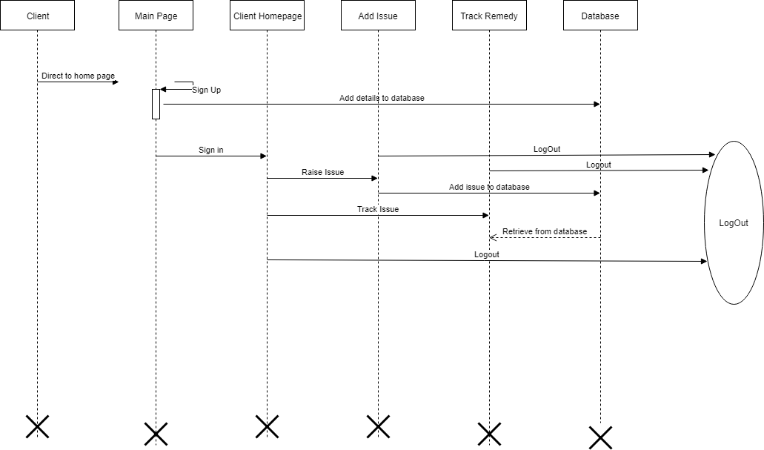
Use Case Model

Business Rules

Business rules should be defined using the following attributes: -

- When the user clicks on the registration link, it should re-direct to registration form.
    - User needs to fill some of the basic attributes/fields as mentioned below in requirement: First Name, Last Name, Age, Gender, Contact Number, User Id, Password
- Clicking ‘Submit’ should validate the datatype constraints for each field
- Post-successful field level validation, save the information in the database
- Upon saving the information in the database, display the message ‘Your details are submitted successfully’.

UI Requirements
Here is a prototype on how the signup should look like.

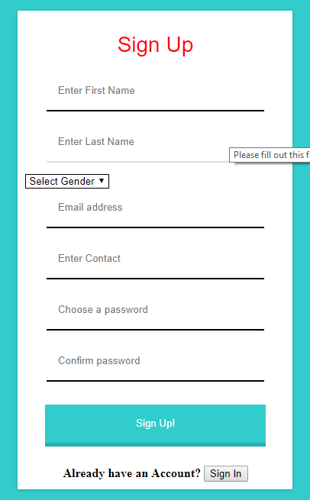

Here is a prototype on how the ‘Client sign in’ page should look like.

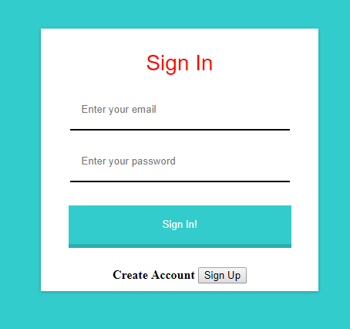

UI Field Validations
Please refer to the below requirements for field level validations:

- All fields are mandatory.
- Username should be less than 30 chars. Password should have minimum 8 chars, no space & can contain special characters (ex.!,@,#,%,*,& etc.)
- Password and Confirm Password fields should be the same
- The Email ID format must be checked. (For ex. test@testmail.com.)
- Phone Number must be of 10 digits’ length

Use case ‘Adding Issue’ & ‘Tracking Issue’

Use case attributes
Use Case Description:

This use case deals with the adding remedy issues and tracking them. The ‘user’ here shall be the operator of the system and will be keying in them.

Scope:

- User remedy adding and tracking.

Actors:

User – the operator

Trigger:

Click ‘Add Issue’, after Login and add issue.
Click ‘Track’, after Adding Issue.

Pre-Condition:

User being able to access the welcome page

Post Condition:

User is in the Tracking the Remedy Issue page.

Flow of Events:

User at homepage → Buttons Add Issue, Track → User remedy details are entered → click Add issue button→ Enter Email → click Track button

Primary Scenario:
A user – is able click ‘Add Issue’, after login and he can add his remedy issue and able to click ‘Track” to track the status of the issue.

Use Case Model

Business Rules
Business rules should be defined using the following attributes:-

A user – is able click ‘Add Issue’, after login and he can add his remedy issue and able to click ‘Track” to track the status of the issue.

UI Requirements
Here is a prototype on how the user add his issue and track.

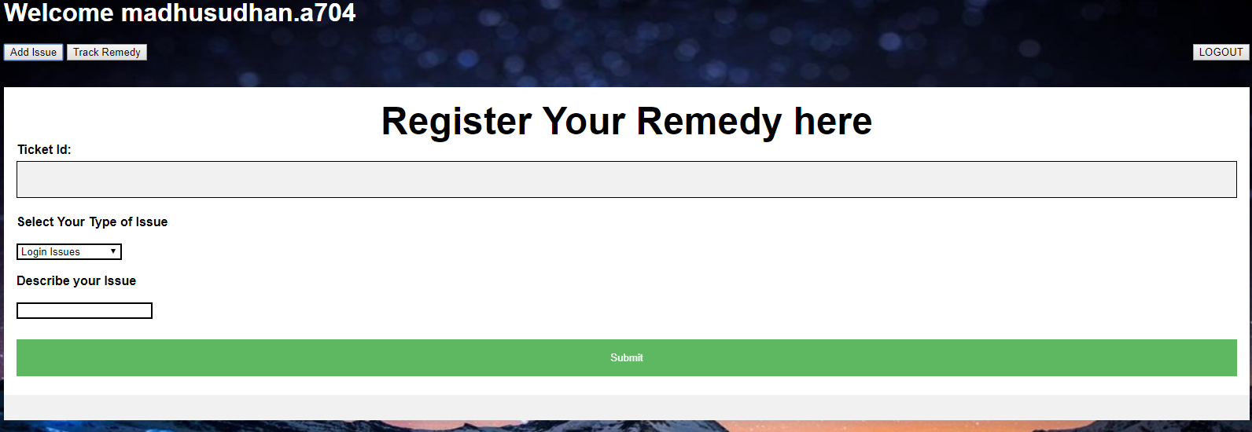

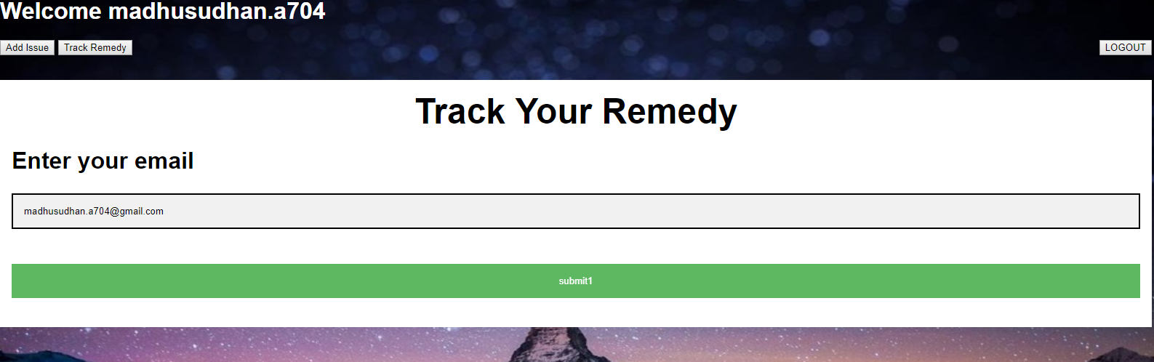

Use case ‘Admin Management’

Use case attributes
Use Case Description:

This use case deals with the managing remedy issues. The ‘admin’ here shall be the operator of the system and will be keying in them.

Scope:

- Issue Management.

Actors:

Admin – the operator

Trigger:

Click ‘Update’, after Admin Login.

Pre-Condition:

Admin being able to access the welcome page

Post Condition:

Admin is in the Managing the Remedy Issue page.

Flow of Events:

Admin at login page →Enter Credentials and click Button Login→ Admin at homepage → Button Update Issue → User remedy details are updated.

Primary Scenario:
An Admin – is able manage the user remedy issues and update in database.

Use Case Model
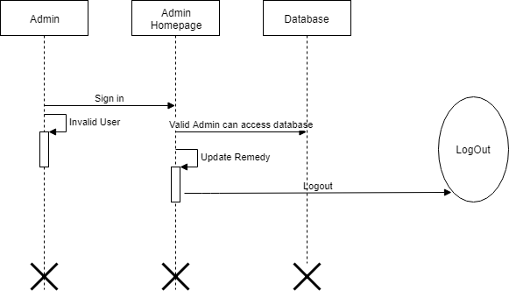

Business Rules
Business rules should be defined using the following attributes:-

An Admin – is able manage the user remedy issues and update in database.

UI Requirements
Here is a prototype on how the Admin Update and manage remedy issues.

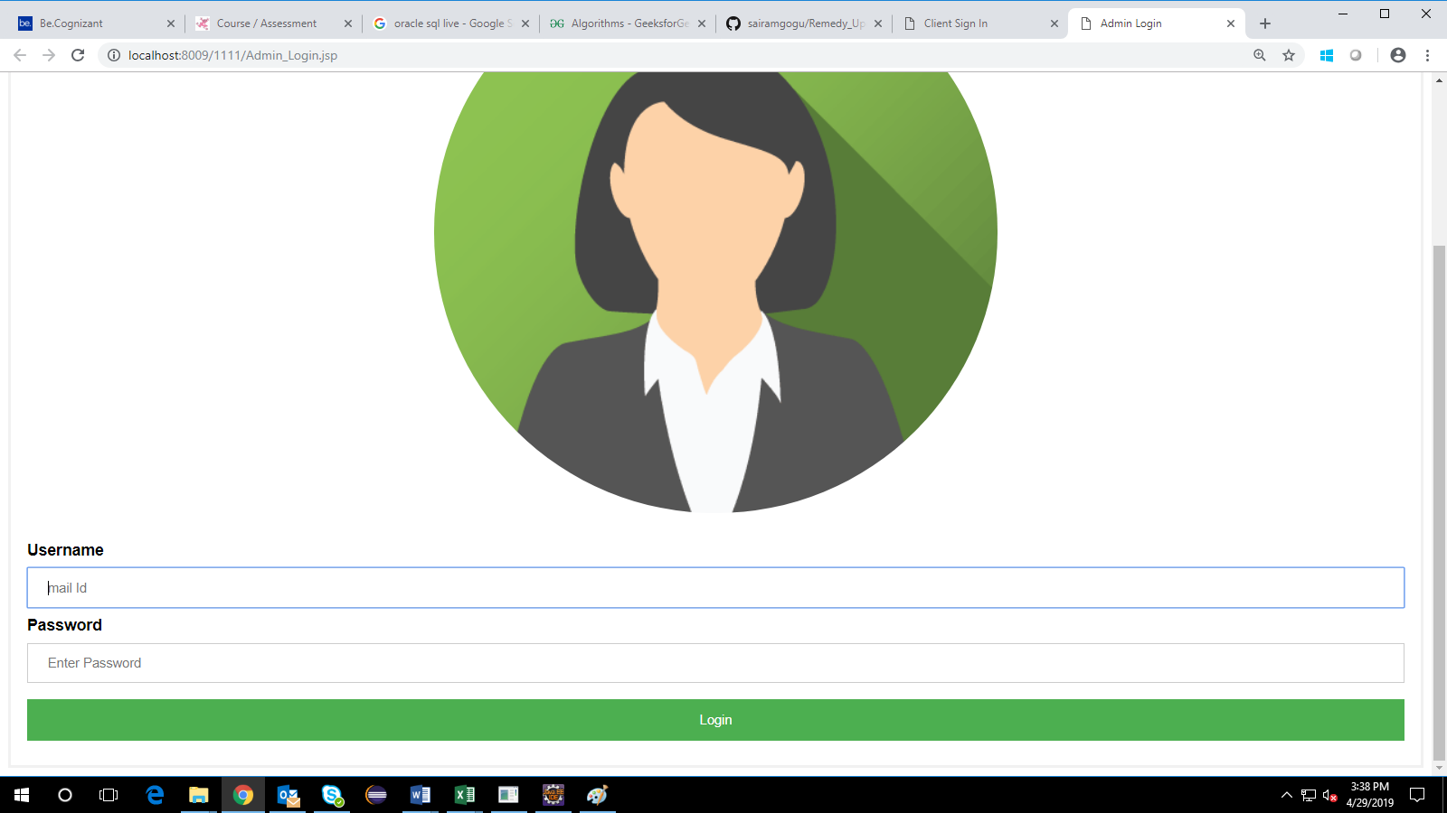

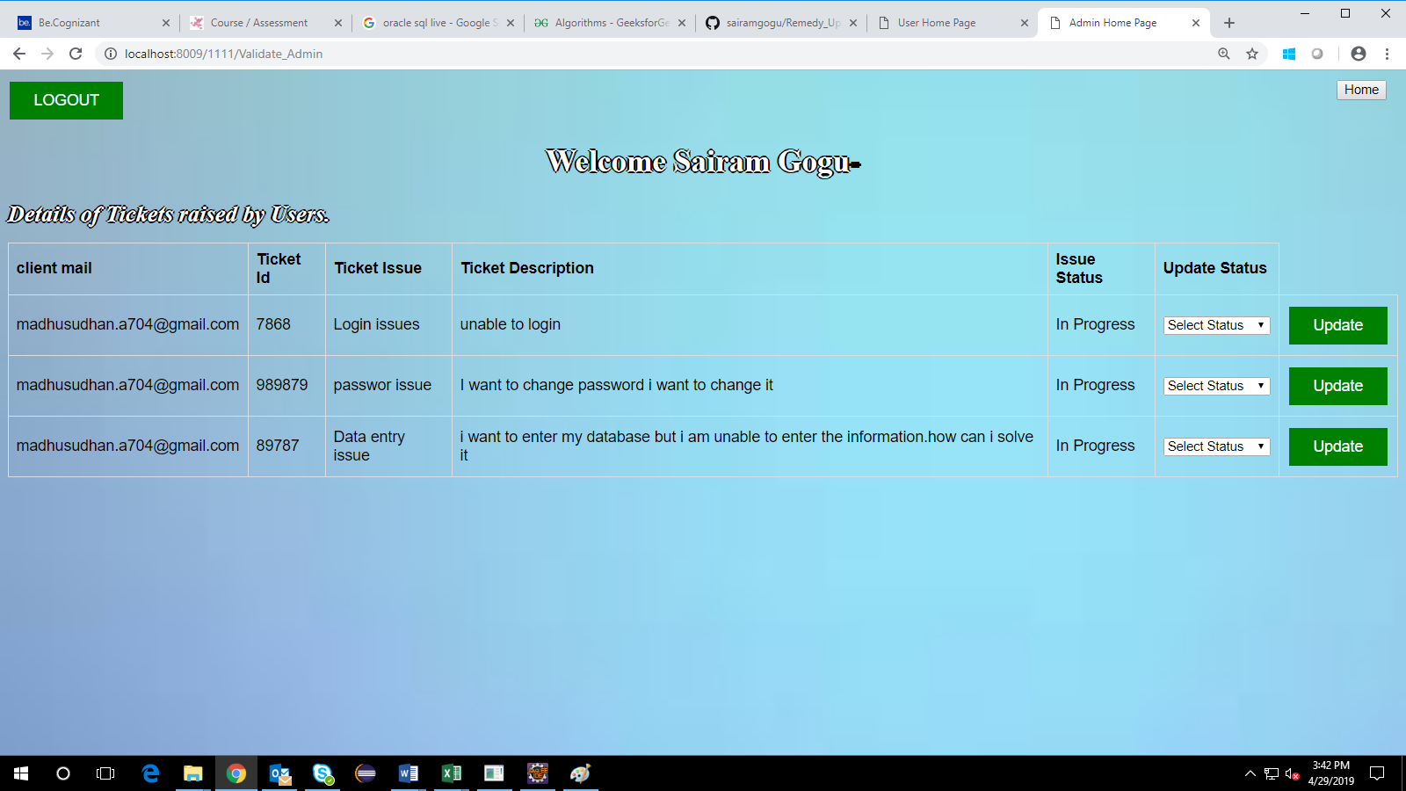

Database Design

Tables Structure
User Registration:

Column Name | Data Type | Length | Nulls
First Name | Varchar | 100 | NULL
Last Name | Varchar | 100 | NULL
Gender | Varchar | 10 | NULL
Contact | Varchar | 100 | NULL
Email | Varchar | 100 | PRI
Password | Varchar | 100 | NULL

Issue Registration:
Column Name | Data Type | Length | Nulls
Email | Varchar | 100 | NULL
Ticket Id | Varchar | 10 | NULL
Issue | Varchar | 100 | NULL
Description | Varchar | 1000 | NULL
Status | Varchar | 100 | NULL

